Note¹: All labs are mandatory and you will be marked on 4, randomly chosen out of 12 labs. These will account for 20% of your overall mark (5% each).
Note^{2:}: If a marker requests for a specific lab (e.g. Lab 3) and you do not have Lab 3 available, you can ask for another lab to be marked (e.g. Lab 2) but the total marks for Lab 2 will be reduced by 50%.
Note³: All the labs should be created on one single document following the provided template, saved in your drive (or computer) and accessible anytime. Labs are individual works and they will be submitted into Moodle dropbox - see deadline.
Note⁴: If a LAB is not finished in the scheduled session you should complete it at your most convenient time by the beginning of the next session.
Note⁵: Use a code editor and do not type into VM directly
Online syntax and technical documentations: https://devdocs.io/

LAB 6

- Connect to the movie_rental database (that you have installed in LAB5 ) and change the phone number from the current one to 02392844444 for address with id 100. Do not alter any other data/attribute.
UPDATE address
SET phone = '02392844444'
WHERE address_id = 100;

- Create a query that will return all the details for the record where the phone number is 02392844444 and use EXPLAIN. Take a screenshot of the output.
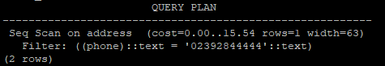
- Apply an INDEX on the phone attribute.
CREATE INDEX phone ON address(phone);

SELECT * FROM pg_indexes WHERE tablename = 'address';

- Use EXPLAIN again. What are the differences? Which one performs better and why?
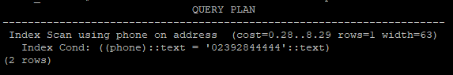
The second one runs better as it’s running through the index
- Delete the INDEX you have created in Q3.
DROP INDEX phone;

- cCreate a VIEW (customer_details) that will hold the customers details exactly as below.
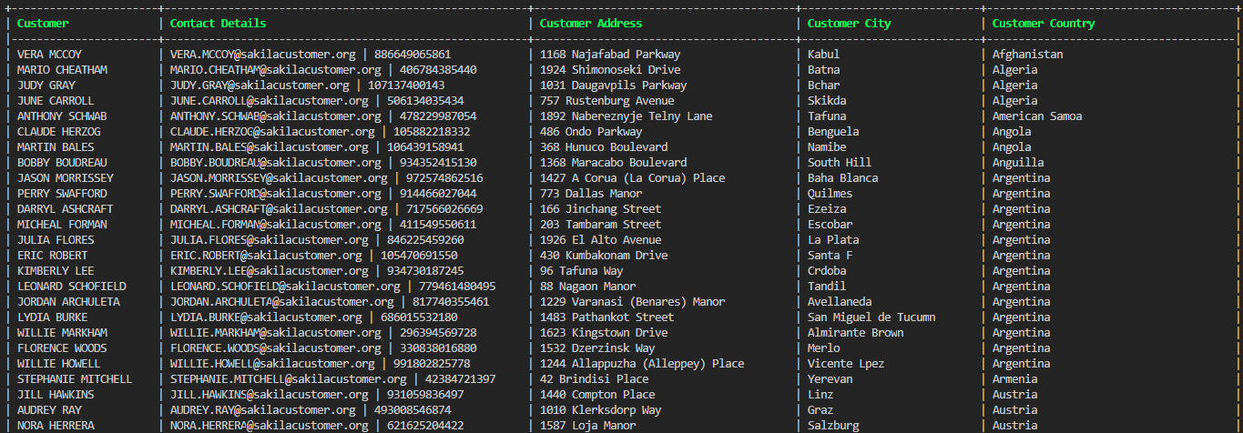
CREATE OR REPLACE VIEW customer_Details AS
SELECT
CONCAT(c.first_name,' ', c.last_name) AS "Customer",
CONCAT(c.email, ' | ', a.phone ) AS "Contact Details",
a.address AS "Customer Address",
ci.city AS "Customer City",
co.country AS "Customer Country"
FROM customer c
JOIN address a ON c.address_id = a.address_id
JOIN city ci ON a.city_id = ci.city_id
JOIN country co ON ci.country_id = co.country_id
ORDER BY co.country ASC;

- Using a subquery list all cities from the United Kingdom along with the city ID.
SELECT
CONCAT(c.first_name, ' ', c.last_name) AS "Customer",
CONCAT(c.email, ' | ', a.phone) AS "Contact Details",
a.address AS "Customer Address",
ci.city AS "Customer City",
co.country AS "Customer Country"
FROM customer c
JOIN address a ON c.address_id = a.address_id
JOIN city ci ON a.city_id = ci.city_id
JOIN country co ON ci.country_id = co.country_id
WHERE ci.city_id IN (
SELECT city_id
FROM city
WHERE country_id = (
SELECT country_id
FROM country
WHERE country = 'United Kingdom'
)
);

- As an extension of the previous query, list the cities from the United Kingdom and France using the IN operator, this time showing the country name as well. Group them by country.

Challenge Questions - This is not marked as part of the lab but is taken into account for general marking.

C1 - Using subqueries, list the concatenated first name and last name along with the email address - as a separate column - of all customers that have rented an action movie. List them in alphabetical order first name then last name.

Note: This query is a difficult one and can be solved in multiple ways and multiple subqueries. As long as you are using at least one subquery for the correct output, it will be a valid query. Look for multiple usage of IN and USING operators.

CREATE OR REPLACE VIEW customer_rentals AS
-- Select customer full name and email
SELECT
CONCAT(c.first_name, ' ', c.last_name) AS "Customer", -- Combine first and last name add email
c.email AS "Customer Email"
FROM customer c
WHERE c.customer_id IN ( -- Filter customers who have rented an Action movie
SELECT r.customer_id
FROM rental r
WHERE r.inventory_id IN (-- Get inventory IDs for the movies rented
SELECT i.inventory_id
FROM inventory i
WHERE i.movie_id IN (-- Get movie IDs for movies that belong to the "Action" category
SELECT m.movie_id
FROM movie m
WHERE m.movie_id IN (-- Get movie IDs linked to the "Action" category in the movie_category table
SELECT fc.movie_id
FROM movie_category fc
WHERE fc.category_id IN (-- Get the category ID for 'Action' movies
SELECT cat.category_id
FROM category cat
WHERE cat.name = 'Action'
)
)
)
)
)
ORDER BY c.first_name, c.last_name;

